Company User
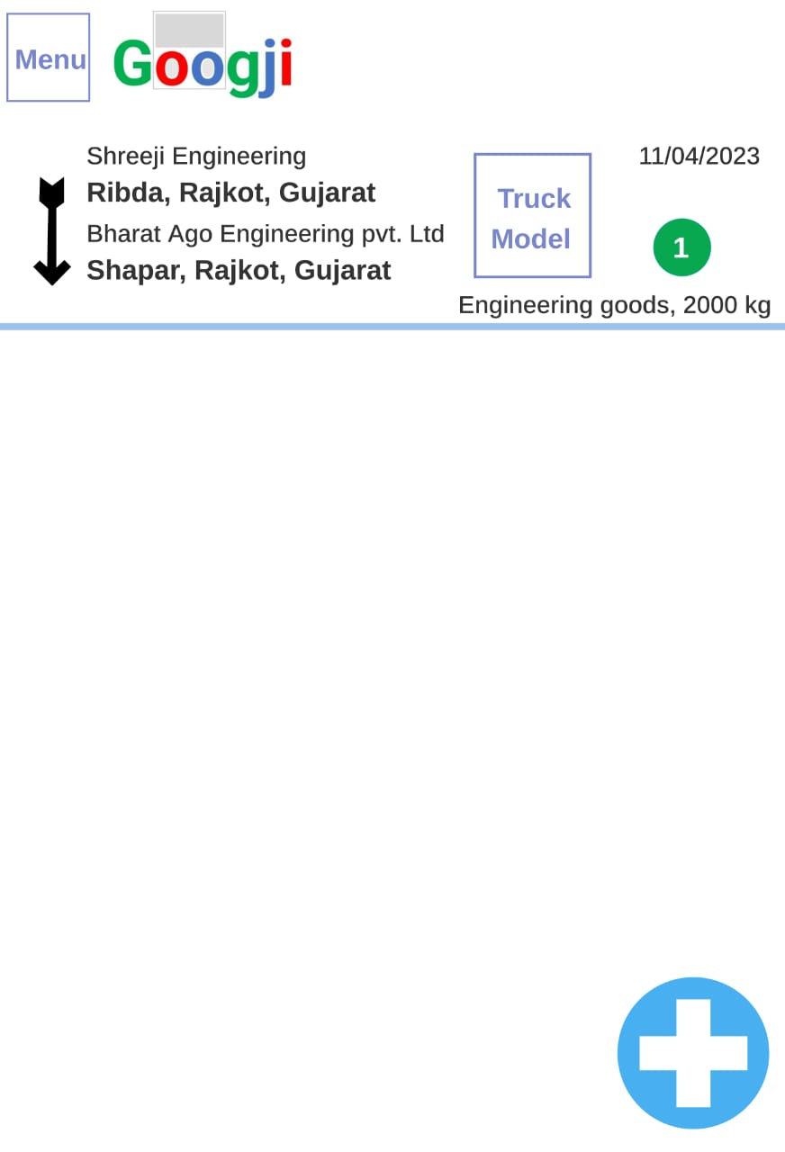
Main screen List of Load those company User Add
Click on + button in this screen, add details of Company user load for find truck
Long click on list of Load for see information, Edit, Delete selected list of Load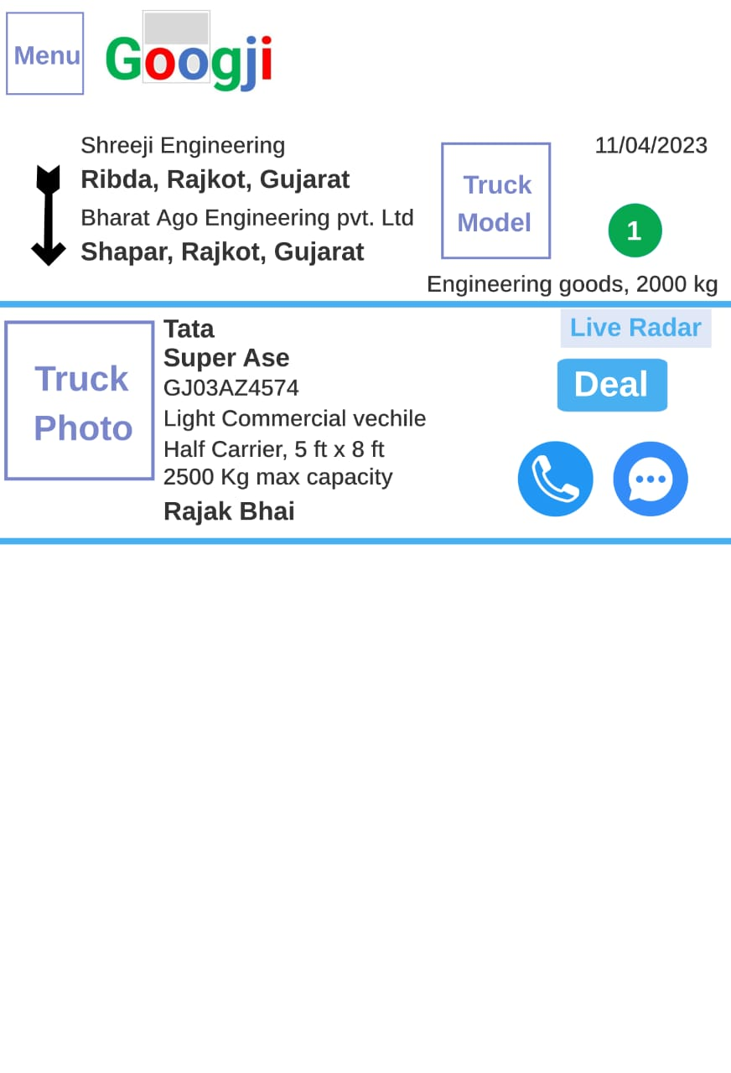
Display when click on list of Load, list of Truck those are available for your Load
Click on Deal when deal done for your Load with truck user, click on call or message for making Load deal with that truck user

Truck User
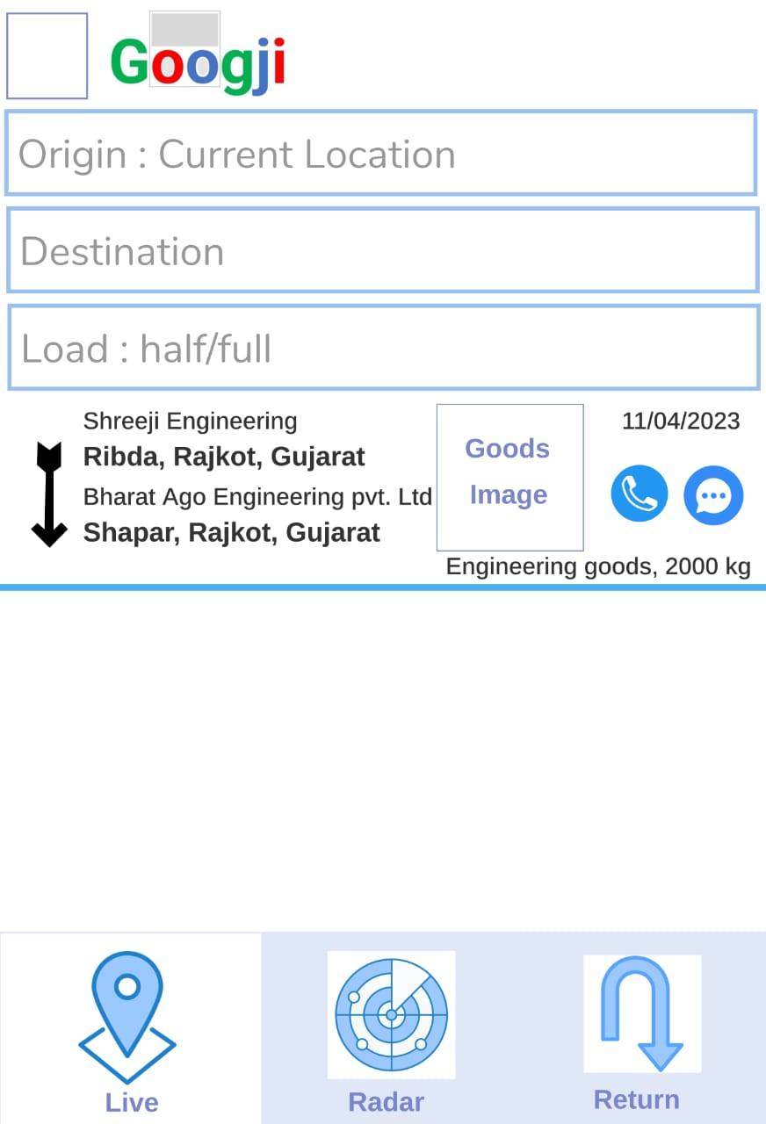
Display on live tab click, List of Load as per truck user live origin (Current location) and destination
If destination is blank, list of Load as per truck user origin (Current location) nearest
Click on call or message for making load trip deal with that Company user
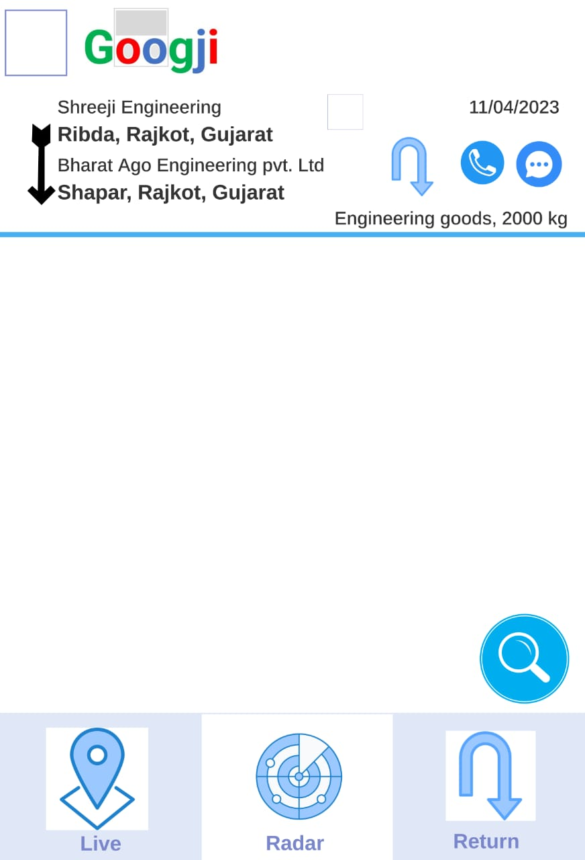
Display on Radar tab click, list of Load as per truck user Radar setting
Click on return button for find this load trip related return load Trip after deal or decide this load trip, Click on call or message for making Load trip deal with that Company user

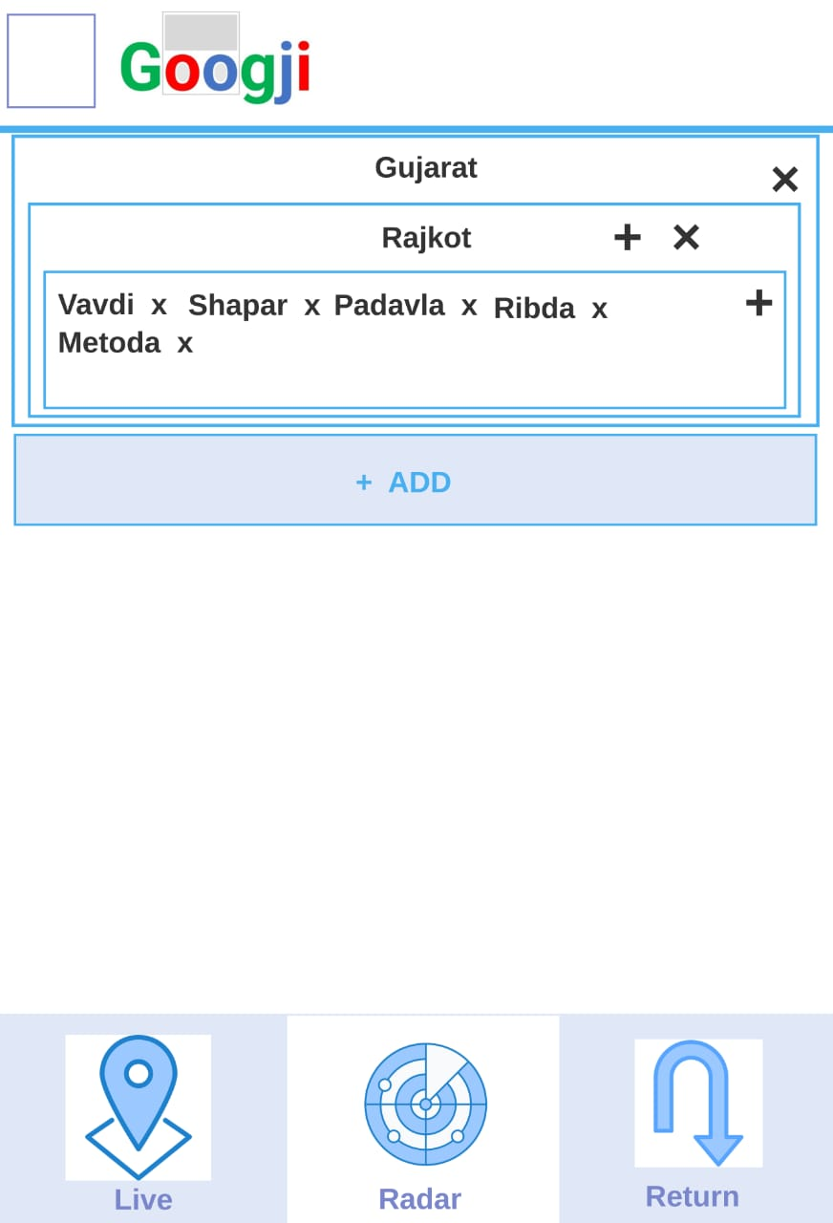
Display on search button on radar tab, setting of radar add (+) or remove (x) state, district, region
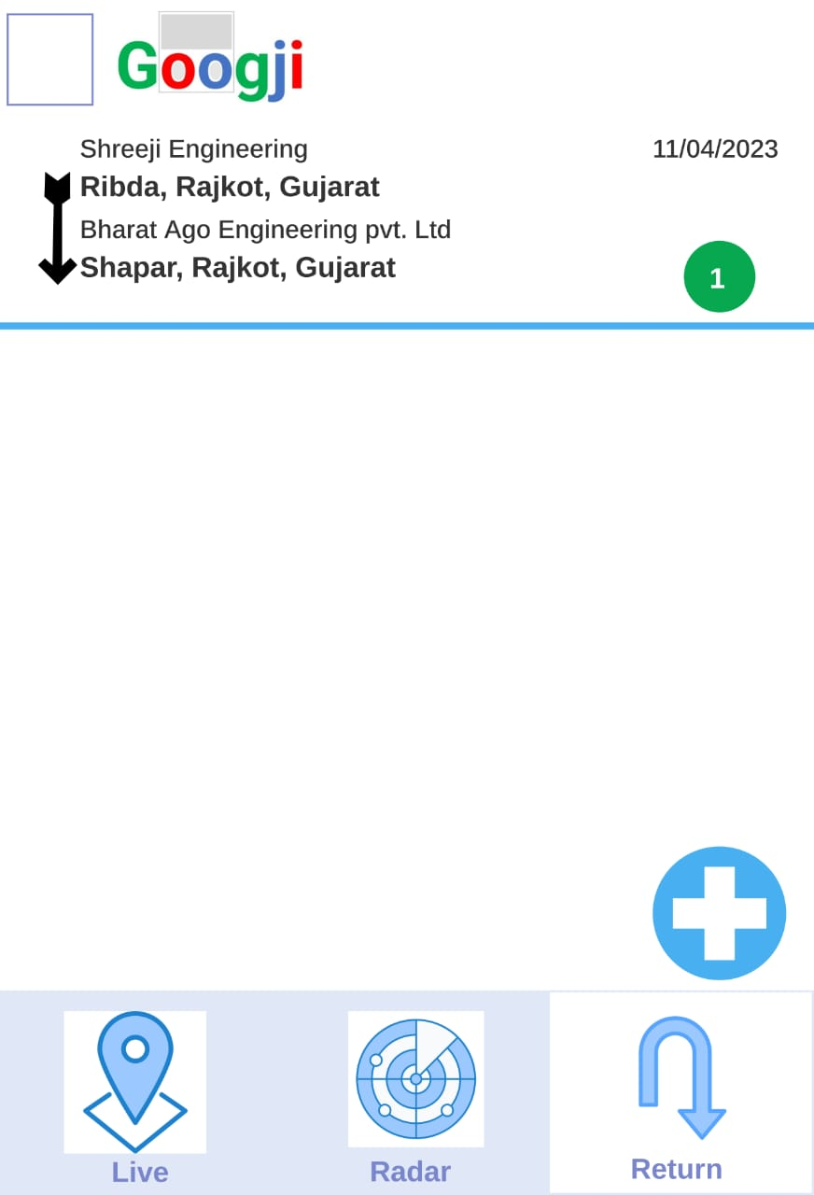
Display on return tab click, list of truck user decided Load Trip as truck user added for find return load trip
Click on + button in return tab, add details of truck user decided Load Trip
Long click on list of Load Trip for see information, Edit, Delete selected list of Load Trip

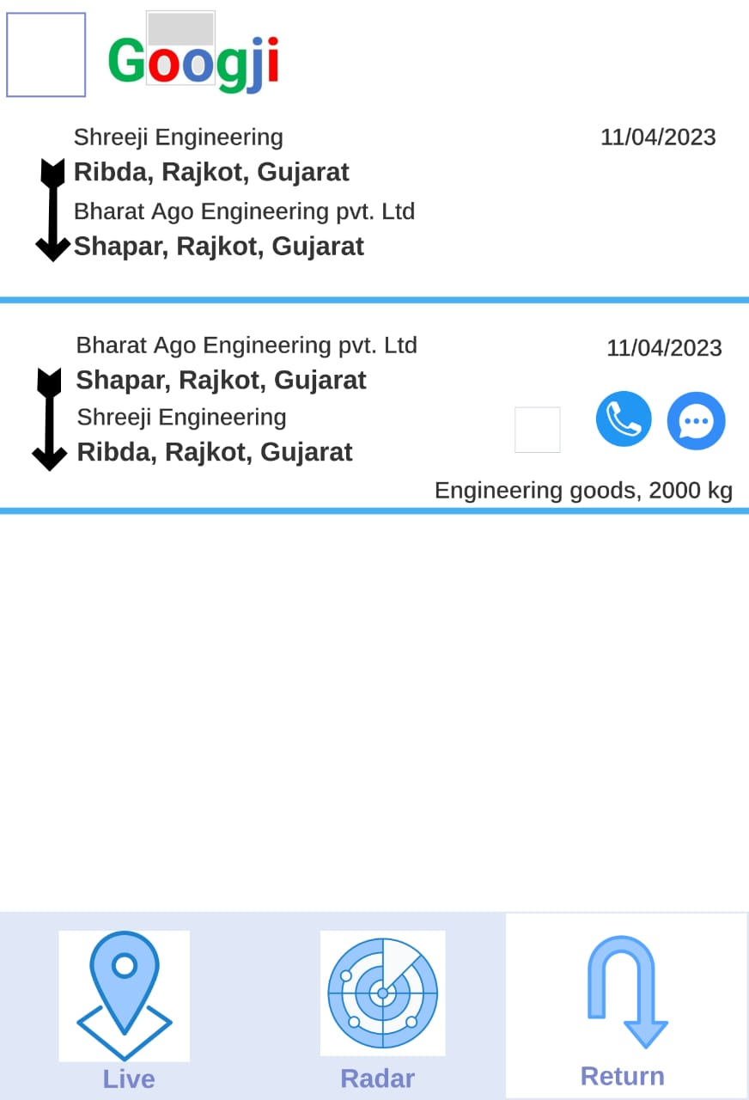
Display when click on list of truck user decided Load Trip, list of load those are available for this load trip return
Click on call or message for making return Load trip deal with that Company user

